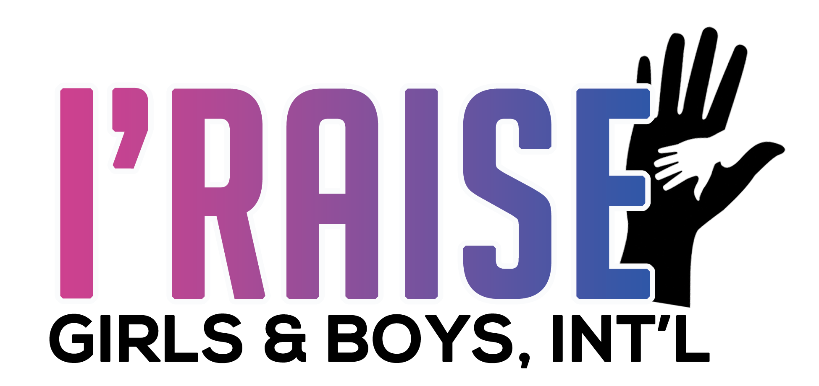

Parental Program Agreement
(For Minors under Age 18)

Dear Parent,

We are excited to inform you that your child has been accepted into the I’RAISE Girls & Boys International Big Brother Big Sister Program! For your child’s participation in the program to be successful, we will need your help. Please carefully read the following agreement to review some important information about the program.

- Due to COVID-19, I’RAISE primarily offers mentoring services virtually, but in-person mentoring may be possible. Please ensure your preference is known by program staff.
- Be clear about the needs of your child.
- Inform the program staff of any learning or developmental disability with which your child may have
- been diagnosed. This will allow the mentor to tailor their activities and sessions accordingly.
- You must provide copies of IEP, during their time in the program.
- Your child’s progress will be monitored throughout the course of the program to determine their level of improvement. Progress monitoring may entail some or all of the following:
- Mentoring services are provided for a specified amount of time as determined by the parent and program staff. As we near the end of your child’s mentoring period, an evaluation will be conducted to determine if services need to continue or if your child has achieved their goal.
- You agree to receive and respond to communications from I’RAISE to request information, obtain feedback on services provided, etc. that will allow program staff to better understand your child’s needs and their progression.
- You agree to receive communications from sharing news of other I’RAISE services or services from other community based organizations that might be of interest to you and your child.
- You agree to the use of your child’s image in marketing materials promoting the mentoring program. enrollment in the program does not guarantee that your child’s photo will be used for this purpose.

Please carefully read the expectations of your child/children during their time in the Mentor program:

- Youth are expected to participate in all scheduled sessions with their Mentor. ( If youth are not able to attend sessions, parents are responsible for notifying staff of absence). Please Initial ________

- I understand if I miss more than 3 consecutive sessions , I will be dismissed from the program.
Please Initial ________

- I understand that all parents and youth are required to attend at least 3 or more Virtual Events hosted by I’raise staff. Events includes; Christmas Karaoke, Christmas Party, Talent Show Casse, Vision Board Mixer, Self Defense , and future events. Please Intial__________

- I understand, if the parent or guardian fails to keep consistent communication with the Mentor or staff, I will be discharged from the Program. Please Intial________

Please sign this agreement and email it to Program Manager Tanequa Moore at T.Moore@iraiseinc.org.

I give permission for my child, youth first and last name, to participate in the I’RAISE Girls & Boys International Corporation. I agree to adhere to I'raise Policy and Procedures.
Parent/Legal Guardian (Print Name)
Parent/Legal Guardian (Signature)
Date

Phone Number

I’RAISE Girls & Boys International Corporation
3640 White Plains Road, Bronx, NY, 10467
Phone: 718-725-8996
Fax: 718-655-4018
hrm@iraiseinc.org | www.iraiseinc.org

